**A CRYPTOGRAPHIC SHARDING ACHIEVE STRIDE SCALING ABILITY**

**Preface**

**TABLE OF CONTENTS**

**1. SOFTWARE DEVELOPMENT LIFE CYCLE**

**2. PLATFORM KNOWLEDGE**

**3. ABOUT PROJECT**

3.1 ABSTRACT

3.2 SCOPE OF THE PROJECT

3.3 EXISTING SYSTEM

3.3.1 DISADVANTAGES

3.4 PROPOSED SYSTEM

3.4.1 ADVANTAGES

**4. BOTTOM LINE AND FUTURE ENHANCEMENT**

**5. SOFTWARE AND HARDWARE REQUIREMENTS**

**1. SDLC (Software Development Life Cycle)**

The Software Development Life Cycle is a systematic process for building software that ensures the quality and correctness of the software built. SDLC process aims to produce high-quality software which meets customer expectations. The software development should be completed within the pre-defined time frame and cost.

**SDLC Phases**

The entire SDLC process is divided into the following stages:

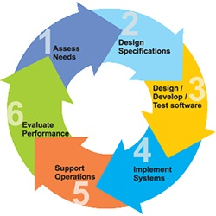

* Phase 1: Requirement collection and analysis
* Phase 2: Feasibility study
* Phase 3: Design
* Phase 4: Coding
* Phase 5: Testing
* Phase 6: Installation/Deployment
* Phase 7: Maintenance

**2. Platform Knowledge**

**Introduction to java**

Java programming language was originally developed by Sun Microsystems which was initiated by James Gosling and released in 1995 as a core component of Sun Microsystems' Java platform. Initially, the language was called “Oak” but it was renamed as “Java” in 1995. The primary motivation of this language was the need for a platform-independent language. Finally, Java is for Internet Programming where C was to System Programming.

**Java architecture**

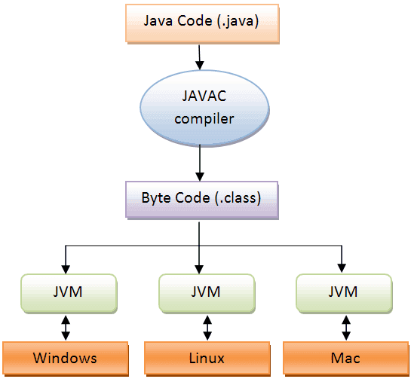Java is a high-level Object-oriented programming language. A program written in high level language cannot be run on any machine directly. First, it needs to be translated into that particular machine language. The javac compiler does this thing, it takes java program (.java file containing source code) and translates it into machine code (referred as byte code or .class file). Java Virtual Machine (JVM) is a virtual machine that resides in the real machine (your computer) and the machine language for JVM is byte code. JVM executes the byte code generated by compiler and produce output. JVM is the one that makes java platform independent.

**A CRYPTOGRAPHIC SHARDING ACHIEVE STRIDE SCALING ABILITY**

**3. about the Project**

**3.1 Abstract**

One of the basic functions of a government is to deliver public services to citizens. Service delivery of this kind requires public expenditure. Hence, governments require resources to finance their expenditure. Although there are a number of different methods available to fund public expenditure, the most important one is taxation. However, governments incur costs when collecting taxes. It is, therefore, important for a government to ensure the efficiency of its tax collection system and to collect taxes in such a way that only minimal costs are incurred. Providing transparent, controllable, secure, and real-time information is vital in terms of ensuring the effectiveness of a tax collection system. There is a lack of industry or government security standards for distributed networks. We proposed a Block Chain technology system to improve the efficiency of taxation system. Where every transactional data will be organized using the technology. A variety of information can be stored on the block chain including tax related data of the citizens of a country.

**3.2 Scope of the project**

Blockchain is a forward looking, highly sophisticated and secure distributed record keeping system which will help in the storage and analysis of large amount of taxpayer database which can be traced down to all past transactions. The system would include all the entities involved in the transaction and hence accord transparent and tamper free transactions. The model is based on consensus and hence all the transactions will have to be validated and approved of, by all the members of the group before the transaction. It is a system based on trust and autonomy which will make the life of at taxpayer easy and the process of tax collection efficient. The concept of Blockchain has taken the fancy of a lot of people and the technology became famous because of one of its most popular use cases. The block chain is an incorruptible digital ledger of economic transactions that can be programmed to record not just financial transactions but virtually everything of value.

**3.3 Existing System**

In existing system from the collation, cleansing and verification of information to the preparation, validation and submission of returns, tax processes are largely paper-heavy and labor-intensive. The **outsiders including individuals, organizations, companies, and foreign governments that want to obtain confidential taxpayer information and to access control passwords and protocols for the purpose of selling the information, blackmailing taxpayers, causing political embarrassment to the tax payers, improving their negotiating position in criminal or civil actions, denying system availability, and modifying or destroying record. Employees, contractors, and vendors who are disgruntled or have been bribed to obtain such information for the above-stated purposes. Taxpayer data were processed on stand-alone systems and moved physically on magnetic tape. So that**

**3.3.1 Disadvantages**

* There is no precedent or culture for secure electronic transmission of sensitive data.
* Storing and retrieving up of large amount of distributed data is quite difficult and less secure.
* There may be security issues arise.
* Calculating and payment of taxes is tedious process.

**3.4 Proposed System**

It is designed in such a way that businesses which had never ever paid taxes in history were all compelled to abide by the law. The government thereby managed to ruffle many an industrial feather. The tax law according to experts is excellent in its drafting and aims for maximum benefit to businesses as well as consumers, and at the same time, increasing the government revenues. As the system becomes transparent, consumers will trust the government more and will co-operate in making the whole system viable and compliance will increase. Every entity will pay the tax directly to the tax authority and hence no question of refunds etc. Blockchain addresses most of the current issues befuddling the government and the taxpayers. Due to the transparency of block chain the tax payers and the government can able to check and verify the tax payment details. As well as additionally the application calculates tax for the PF amount and without third party servers, the users can apply and claim the amount. The scalable architecture effect of block chain will provide much more reliability on the stored transactional data.

**3.4.1 Advantages**

* The administrative burden of calculating tax on the part of companies will be drastically reduced. Lot of time and energy would be saved. Cost of accounting services will be reduced.
* A huge repository of taxpayers data will be collected which can be traced to all past transactions.
* One would be able to get immediate data about the fundamentals of the companies on the network with respect to their finances, delivery time, and payment histories.
* They will be tamper proof and no one will be able to make any changes to them later.
* The central authority will be able to garner more trust from the taxpayers and compliance will increase.
* The ledger cannot be altered or tampered with once the data is entered. Fraud is less likely and easier to spot.

**4. Bottom line and Future Enhancement**

While block chain is not the cure all for the tax system, it could be applied in a number of areas to reduce the administrative burden and collect tax at a lower cost, helping to narrow the tax gap. The Internet revolutionized the way information is exchanged, block chain is transforming the way we exchange value The Block chain is a forward looking highly digitized system. Taxation systems as a use case of Block chain were discussed and analyzed. Every government desires minimum leakages in their tax revenues.

Block chain holds a lot of promise and governments all over the world are quite excited about implementing blockchain in the tax systems. The government will have to rope in data scientists land IT professionals to design a blockchain platform for GST. With the current government and its emphasis on digital India, Block chain seems to be the ideal solution for efficient tax collection.

**5. Hardware and Software Requirements**

**HARDWARE REQUIREMENTS:**

* Processor : Intel (R) Pentium (R)
* Speed : 1.6 GHz and Above.
* RAM : 4 GB and Above.
* Hard Disk : 120 GB.
* Monitor : 15’’ LED SVGA
* Input Devices : Keyboard, Mouse.

**SOFTWARE REQUIREMENTS:**

* Operating system : Windows 7 / 8 / 8.1 / 10.
* Coding Language : JAVA / J2EE.
* Java Version : jdk 8.
* IDE : Eclipse Oxygen.
* Database : MySQL v5.1.
* Database Tool : HeidiSql v11.0.
* Application Server : Apache Tomcat 8.X / 9.X.